Let’s see how can we connect Azure Container Registry(ACR) from Docker Toolbox so that we can create and push the images to ACR.


To know the username and password- Navigate here on Azure
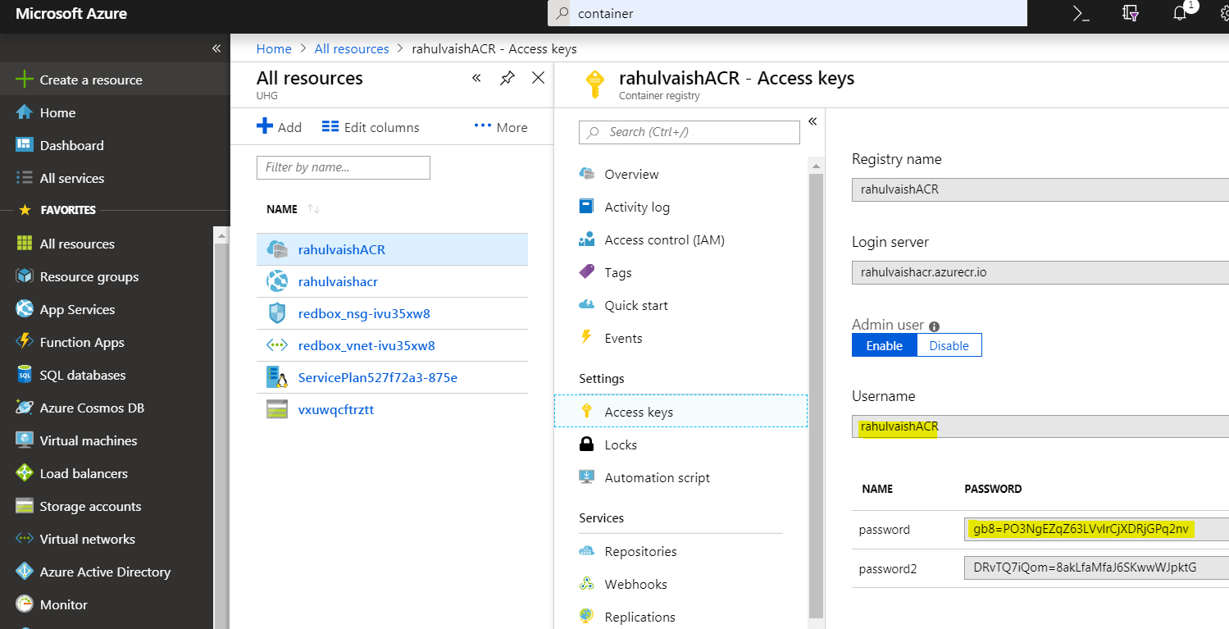
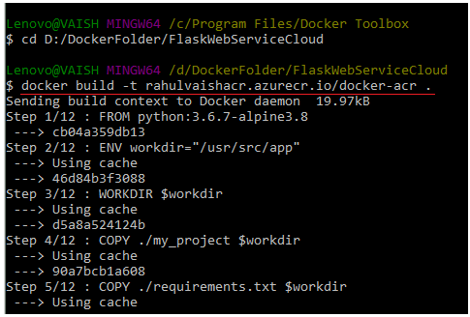
You can also tag the image like we always used to do..
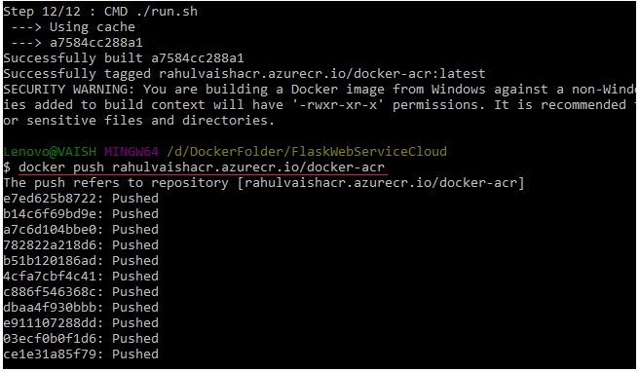
Now check on the Azure Side
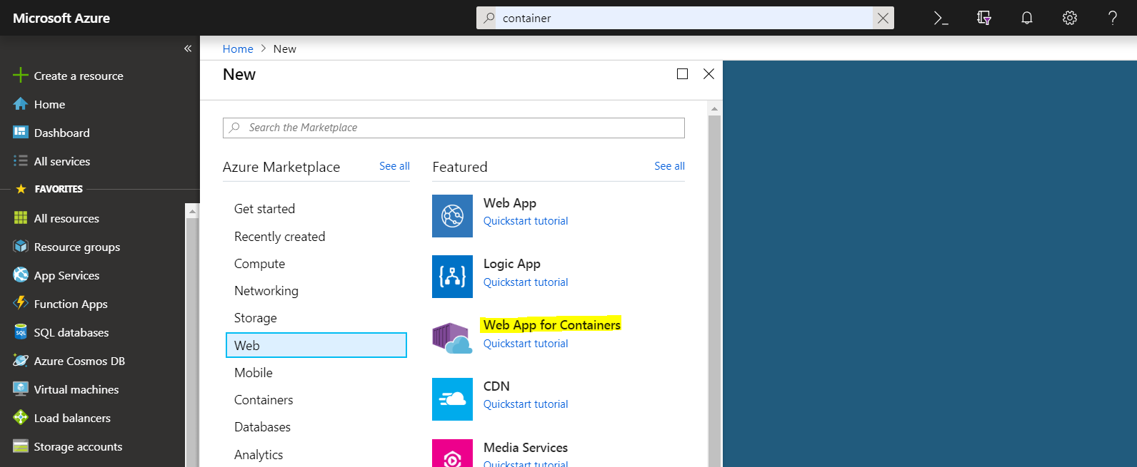
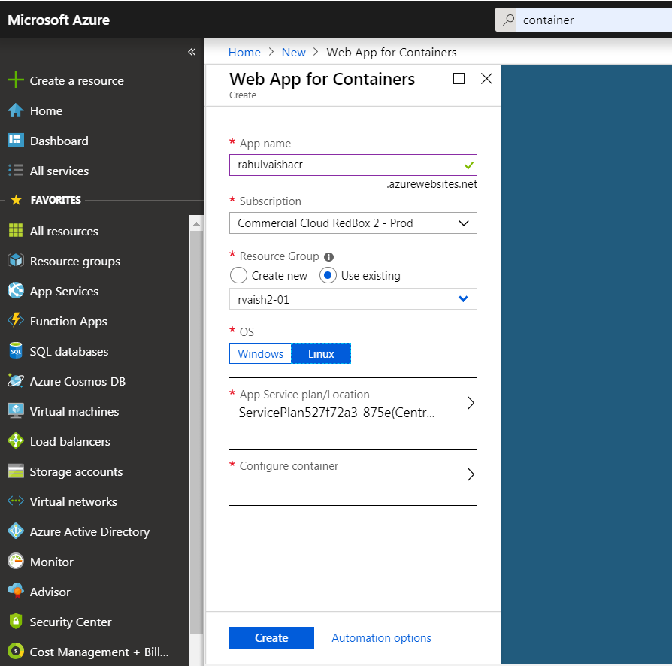
Now click on Configure Container. This time we will select ACR, not Docker Hub. The values will come automatically after we have pushed the imageon ACR. We can see docker-acr in the dropdown ☺
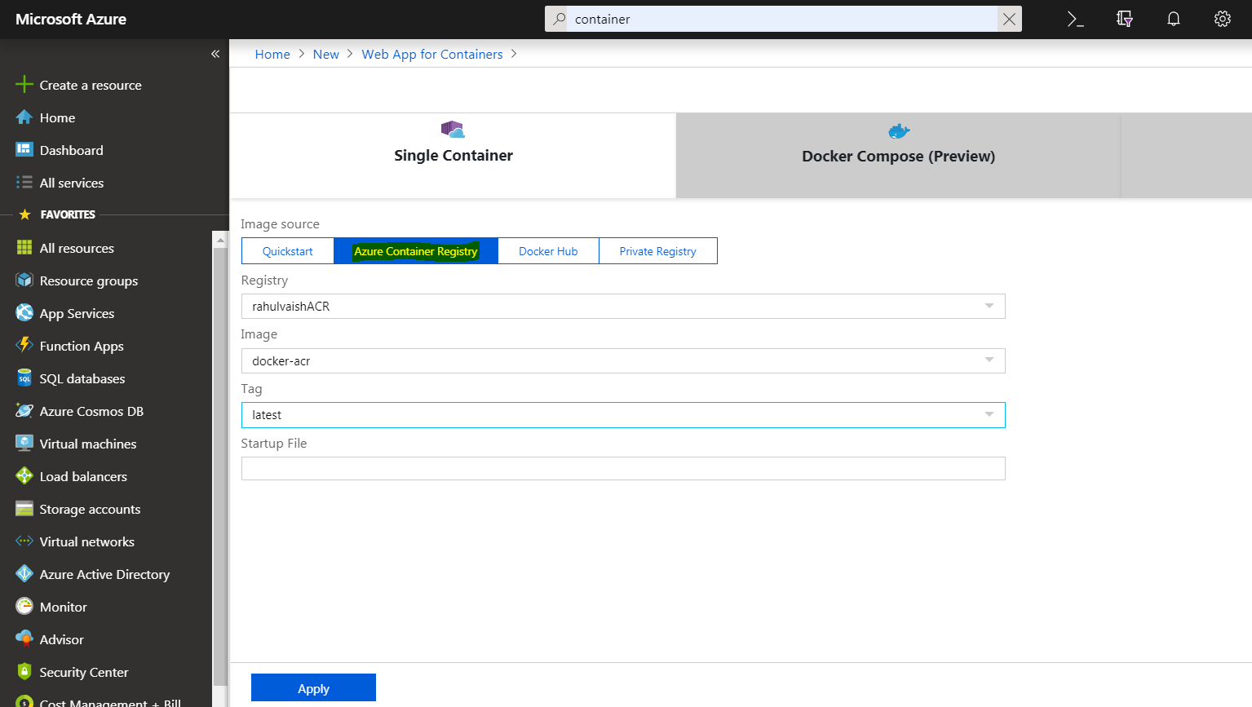
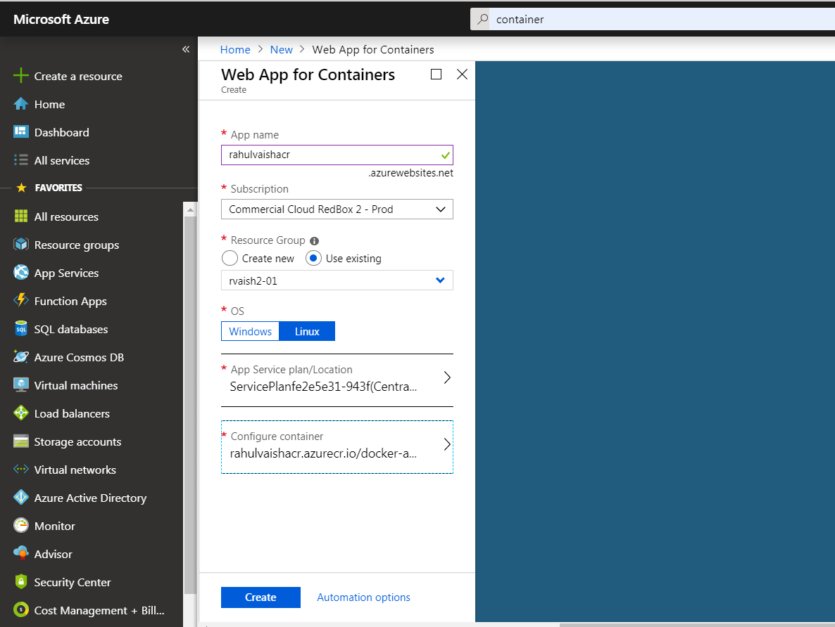
On clciking create, the resource gets creaed ☺

